IDDSI production and process: Building IDDSI in to your day
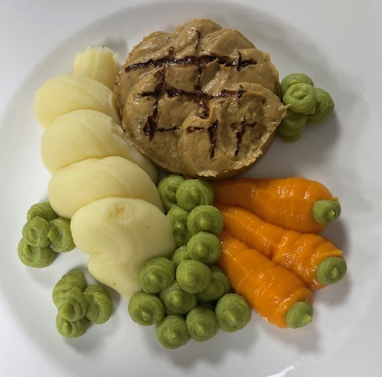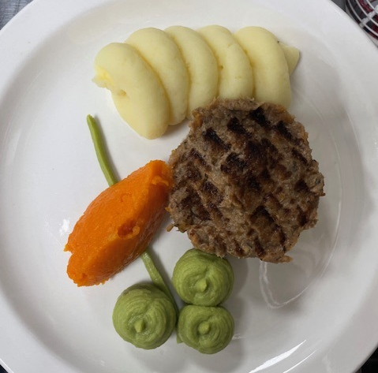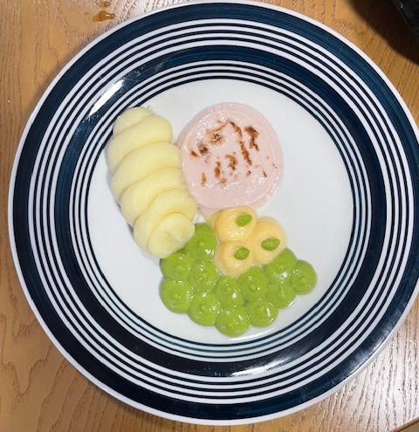
- Menu planning: Is the menu planned with IDDSI in mind?
The menu should be planned to consider foods that can be modified.
Where menus are cooked fresh, ingredients can often be precluded before the dish is prepared e.g. chicken pieces can be precluded before being breaded and then cooked correctly to retain moisture and reduce crusting/ skin forming . This will help to ensure that all residents receive the same flavours as each other. Menus need to meet all resident’s needs.
Recipes should consider cooking methods. Where possible poach, braise, stew or steam (PBSS) to maintain moisture. If roasting foods, hold back suitable numbers for IDDSI meals and use moisture holding cooking methods (Poach, Boil, Steam, Stew)
- Daily planning
Think about the ingredients you plan to use. Prepare with IDDSI in mind. Cut vegetables to 15mm x 15mm
Don’t forget breakfast and snacks in your menu consideration as choices are needed in all areas
Check your menu for the day to ensure it offers choices for those needing a texture modified diet

- Kitchen set up
- Identify your prep area
- Display the IDDSI A3 poster at your point of prep, laminated
- Display the IDDSI audits foir each level including fluid
- Ensure the IDDSI audit summary is to hand near prep area (this is in your HACCP)
- Ensure you have a non-toxic permanent marker
- Ensure you have IDDSI information folder to hand for recipes, framework and this process and production guide

- Equipment
Make sure you have the right equipment before commencing with IDDSI preparation
- A suitable machine with high revolutions (above 2000rpm) e.g. robot coupe blixer, Metcalfe Trinity Pro, Thermomix
- Digital scales for testing pressure for Level 5 and 6 and 7EC
- Viscgo forks for testing Level 6 https://viscgo.com/viscgo-fork/
- Robust sieves which don’t easily disconnect from the rim
- Ladles (to push through the puree)
- Metal standard Dinner forks
- Teaspoons
- Bowls
- Piping bags (recommend pink ones and blue ones as they are thicker for hot foods)
- 500ml Jug which the piping bag can sit in to (sieve directly in to the piping bag in the jug)
- Small jug for hot water to cleanse the spoon and fork between testing.
- Silicone square spatula
- Catering paint brushes for presentation
- Square cutters
- Round cutters
- Food based thickeners and thickeners from manufacturer
- Greaseproof paper
- Food based thickeners and thickeners from manufacturer
- Squeezy bottle with nozzle for liquid
- Spray bottle for fluid to moisten foods
- Suitable service pots for attractive service e.g clear plastic or glass pots for biscuits and cake
Ensure you know how to operate and dismantle any equipment safely.
Pink piping bags: Kee-Seal Ultra Non Slip Piping Bags 21" Pink Pink 21" (1 x 72) (allianceonline.co.uk)
Silicone moulds: https://welcometoable.co.uk/welcome-hcs-customers-silicone-food-moulds/

- Preparing, produce, present, serve

Pre preparation could include techniques to soften foods, dry blend foods e.g. Soak herbs or dry blend to powder, tenderise meat, marinade meat, stew apples, use different vegetables

Preparation and cooking for multi-item main meal
- Cut all vegetables to 1.5cm x 1.5cm to make it easier for Level 6 foods
- Explore if you can use alternative methods of cooking meats so that it will be soft and tender e.g. poach, braise, stew or steam. It may be that you cook a smaller meat joint differently for modified meals.
- If you need to , consider cooking vegetables separately for longer if they need to be more tender
- Seal meat before poaching, braising, stewing, steaming
- For mashed potato, soften further with milk and mash by hand, then sieve using a ladle in to a piping bag
- Cook as per recipe, excluding problematic foods that can’t be altered through blending

Production for a multi-item main meal:
- Portion item by item
- Protein: check and discount if it is a problematic food e.g. crusts, husks, THIS IS INAPPROPRIATE FOR USE AND CANNOT BE USED
- Portion in a bowl the total numbers of IDDSI portions required for protein, carbohydrate and vegetables and separately portion in bowls ready for preparation.
- Take cooked protein product, portion off any numbers for level 6
- For remaining portions of protein left in the bowl (for use with Level 5 and 4), add to blender, pulse and test IDDSI level using fork and teaspoon for Level 5. Add liquid OR thickener as required to meet the IDDSI audit critical tests. When suitable, portion off Level 5 in a piping bag
- Continue blending remaining food to Level 4. Test whilst in the blender, adding liquid or thickener as required. IF YOU CONTINUTE THIS TOO MANY TIMES THE FOOD WILL DILUTE AND NO LONGER CONTAIN THE AME NUTRIENTS SO IT IS BETTER TO DISPOSE OF AND START AGAIN
- Taste test, one taste, no double dip of spoon
- Sieve Level 4 in to a piping bag, using a ladle 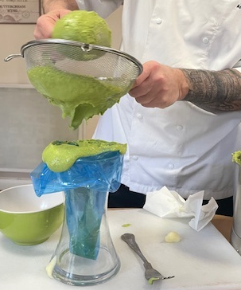
- Remove air from the piping bag and tie with cling film at the top. Cut top of piping bag.

- Place piping bags in hot water steam bath or steam oven wrapped in a heat resistant cloth
- When adding any liquid to thin foods, enrich with flavours and nutrients such as skimmed milk powder, stock, marmite in liquid, custard, orange juice, peanut butter in milk, balsamic vinegar glaze
- If using thickener, use food where possible such as dried rice powder, semolina, potato pearls. Food based thickener may be more appropriate than drinks thickeners.
- Repeat steps 1-7 for starch and vegetable until required texture is reached, washing the bowl between new ingredients.
- Ensure all tested foods are documented in the IDDSI audit summary referring to the IDDSI audit tools

Presentation
Use piping bags for Level 4 and 5, hand under, hand over to portion each
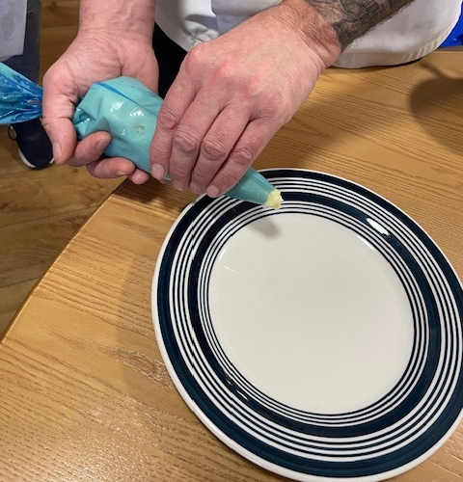
Portion each item, shaping in a pastry cutter too as needed

Service
- Plan service to minimise hot holding
- Label piping bags with the IDDSI level (use sharpie or equivalent)
- Label plate with the IDDSI level, resident name as a minimum if the server cannot directly see the resident to ensure safety
- Present on the plate, starting at the centre of the plate, shaping to represent the food
- Test to ensure it has maintained the correct IDDSI Level accordingly
If foods cannot meet critical testing for Level 5 or 6, blend to a level 4.

Tips
- Have a jug of hot water beside you when using teaspoon and fork to text so you don’t get residual build up which can affect critical test result
- Starches need serving as soon as possible
- Do not serve on to plates until point of service so the food doesn’t not develop a crust or start to dry out
- Use square edged spatula to get all content from bowl
- If using skimmed milk powder, blend with a little milk beforehand to avoid possibly grainy texture. This works for porridge
- Modify hot where possible and appropriate to the food
- Thicken slowly by adding ¼ tsp at a time of thickening agent
- When using the fork or spoon for critical testing, load one mouthful only
- When using the fork, hold it tip down after portioning one mouthful to observe the food texture
- When food meets the texture in the blender, don’t then scrape back the lid contents as this may affect the texture just tested
- 4mm is the measurement between the tines (prongs) of a fork
- 15mm is the measurement between the inner tines of a fork

IDDSI tips , preparation, production and presentation
- Keep the edges of cakes for dry blending, before then adding liquid and thickeners as required

- Chocolate creams, ginger biscuits and custard creams can blend well with flavoured liquid for a texture modified snack

- Whilst doing cake mixtures, remove mixture before adding nuts or problematic ingredients if using for texture modified dishes.

- Liquids such as remaining juice from tinned fruit, apple juice and orange juice blend in as alternative fluids for cakes and biscuits

- Both Modification and fortification is often required together. Skimmed milk powder, in the correct quantity blended with a little milk is also an alternative enriched fluid.

- Starches need to fully saturate before blending and can continue to thicken. You will need to retest carbohydrate foods if you are holding hot or cold
- Test the blend of sweet mixtures using your thumb and finger parting 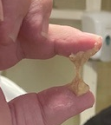

- Some biscuit and cake mixes can be kept for 3 days once modified. Test before serving.

- Blended fruit daily can be popular for many residents, not just those needing a modified diet.

- Layer desserts in individual clear portions. Try to build in height rather than smooth to reduce the risk of the food drying out

- There are more modification recipes on these sites ALTHOUGH PLEASE NOTE ALL FOODS STILL REQUIRE CRITICAL IDDSI TESTING TO ENSURE THEY ARE CORRECT SAFE TEXTURE FOR REQUIRED LEVEL

- Shortcut ingredients include passata, soya mince, yoghurt, custard pots, potato pearls,

